**EE387: Signal Processing**

**Lab 4: Filter Design using MATLAB**

Ranage R.D.P.R. - E/19/310

**1. Design the Butterworth filter with the following specifications: Fp = 1000 Hz; Fs = 5000 Hz;**

clear all;

Fp = 1000; Fs = 5000; Fsample = 10000;

Wp=Fp/Fsample;

Ws=Fs/Fsample;

[N,Wn]=buttord(Wp,Ws,3,30);

[zeros_,poles_,scale_]=butter(N,Wn);

[num,den]=butter(N,Wn);

tf=zpk(zeros_,poles_,scale_);

bode(tf);

figure;

freqz(num,den,5000,Fsample);

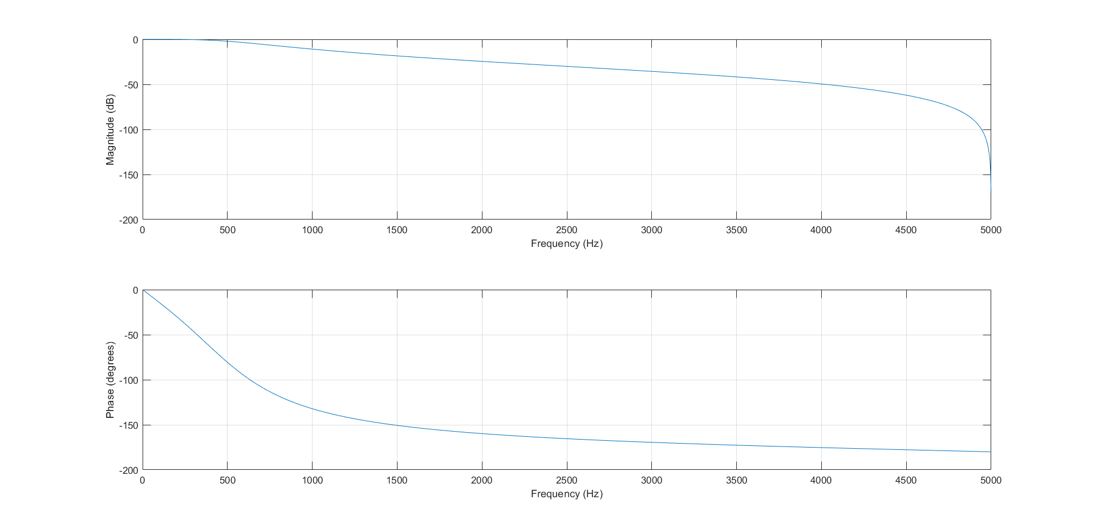

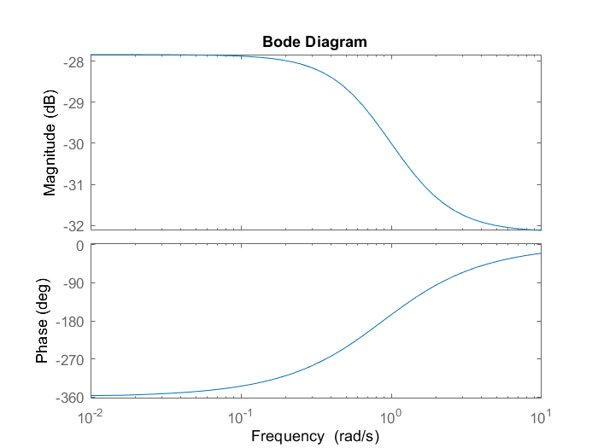

**2. Design the Butterworth filter with Fp = 1000 Hz, N = 4.**

clear all;

close all;

N=4;

Fp=1000;

Wp=2*pi*Fp;

[num,den]=butter(N,Wp,'s');

fil=tf(num,den);

bode(fil);

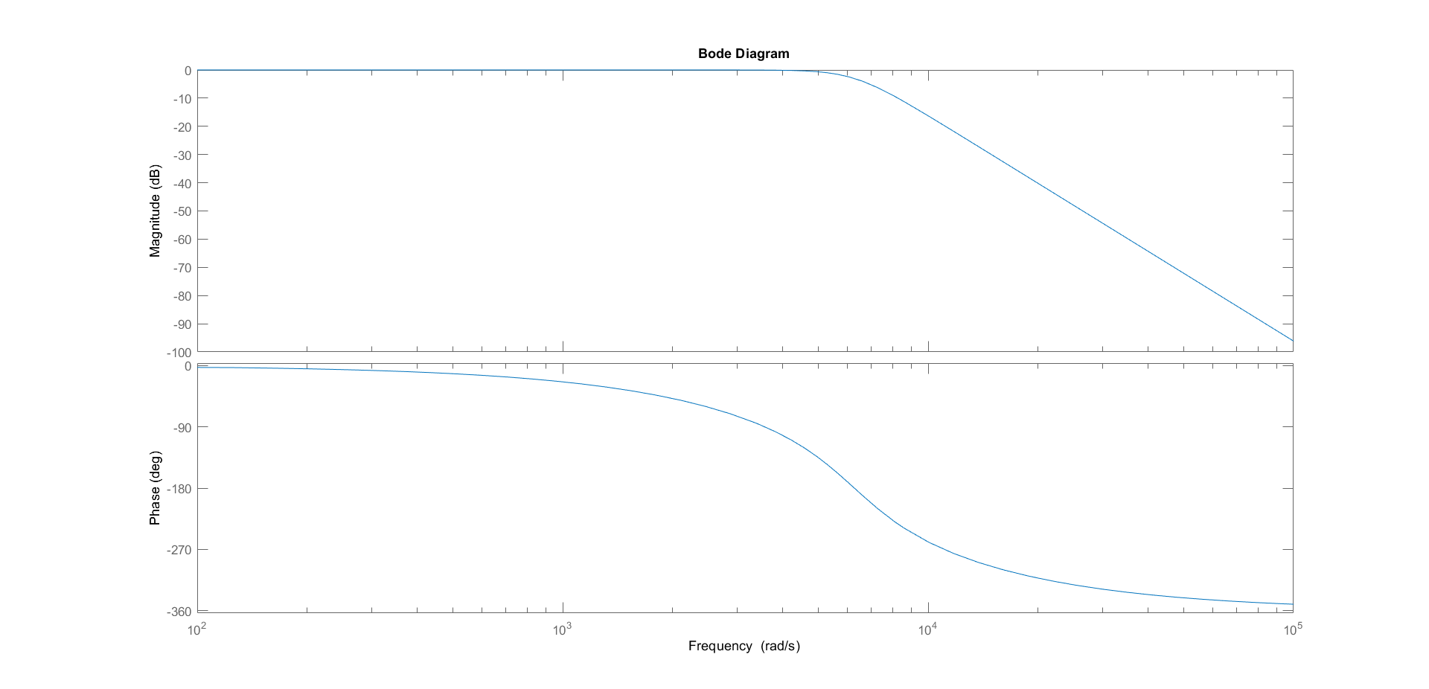

**3. Design Chebyshev Type 1 filter with N = 4, Rp = 2 ; Fp = 1000.**

clear all;

close all;

N=4;

Rp=2;

fp=1000;

Wp=2*pi*fp;

[num,den]=cheby1(N,Rp,Wp,'s');

fil=tf(num,den);

bode(fil);

